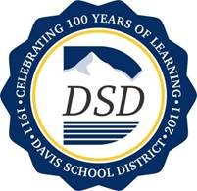
Online Learning Options in Utah

Introduction to Online Learning
Online learning is another education choice. Specifically, it is educational instruction and content delivered primarily over the Internet. (Watson & Kalmon, 2005). The term Online learning is used interchangeably with Virtual learning, cyber learning, or e-learning.

Reasons to Choose Online Learning
Students use Online Learning to receive credit for H. S. Graduation. It allows students the flexibility to:
- Make room in their school schedule for other courses.
- Take courses not available at their school.
- Accommodate elite sports schedules.
- Meet early graduation requirements
- Continue their education while managing health issues.
- Meet scholarship guidelines

Districts Offering Online Learning
Students are not required to take online courses. Most school districts have been offering online learning options for their students, however, In 2011, SB65 was signed into law, which made it mandatory for all districts in the state of Utah to offer online learning for students in grades 9-12.
All of the Online Learning Options are not the same. It is important for students and parents/guardians to research all options fully and choose based upon student’s learning needs.
Consider the following:
- How do you want online to fit in your life?
- When do you plan to do your coursework?
- Do you want to take a class in addition to your full schedule, or are you replacing a class period and leaving campus to go do it?
- Is this for original credit, credit recovery, or accelerated credit?
- Do you need a teacher in the room, or can you work independently and finish work on schedule?
- Do you have the technology and connectivity at home?
- How are your computer skills?
- Do parents/guardians understand they are the learning coach, and expected to monitor activity and grades, respond to emails and assist with successful completion?

Eligibility to Take an Online Course
All 9-12 grade students enrolled in a public or private school, and have a custodial parent/guardian who is a resident of Utah are eligible to take an online course.

Types of Online Options
Online choices are classified 2 ways (these options are provided in chart form in “Table 1” below). Keep in mind that the online options being reviewed are for students in 9-12 grades.

District Programs (USC)
- Offered by the school district and not listed on Statewide Online Learning Provider's list
- Does not require CCA (Course Credit Acknowledgement Form)
- WPU funds stay with student's school of Enrollment
- For Original Credit or Credit Recovery
- Can take 2 credits in addition to or in place of regular school schedule
- Constrained by quarters, see website for dates
- Courses require a final proctored exam
- Instructors are licensed Utah Educators from Cache, Davis, Jordan, Murray, Nebo, Park City and Tooele School Districts
- NCAA Approved
- Register with your school counselor
- Available to students in Cache, Davis, Jordan, Murray, Park City and Tooele School Districts

Statewide Online Education Program (SOEP)
- Created by SB 65
- Requires a CCA
- Removes WPU funds from student’s school of enrollment
- Student can only take Original Credit courses
- Not available in summer
- Student must drop number of registered credits with provider from school schedule and leave campus.
- Contact each individual Provider for information about their courses

Additional Online Options
Contact each individual district online representative for information regarding any other Third party providers that are not listed with any of the options above. Each school district has enrollment policies which must be met.
District Contact List

Full-time Online Enrollment
Currently the participating districts do not have a full-time Online High School. Some Statewide Providers such as EHS, offer a full-time schedule, however the following apply:
- Students must meet the individual School Districts registration requirements.
- Once accepted, student is no longer enrolled in a District school.
- Students may have to travel to their online school’s location to take end of year exams.

A student wishing to attend an online high school full-time may find some options in the Statewide Online Education Program’s Website.
SOEP’s Website

Taking more Online Credits than Allowed through SOEP
Talk with your counselor if you are interested in taking more than a regular school day’s schedule with an Online Provider from the SOEP. This option may be possible if it is found to be in the best interest of the student and requires a change in the students CCR/SEOP.

Table 1: High School Credit Options
PROGRAM | HOW TO GET INVOLVED | DETAILS OF PROGRAM
UTAH STUDENTS CONNECT  (Online Program) | See Counselor to sign up | - Grades 9-12  - Allows you to attend traditional school and earn original credit or credit recovery to increase flexibility in your schedule or to speed up graduation  - No cost, except class fees  - Accessed through “Canvas” LMS  - Can earn up to 2 credits per year in addition to your traditional school schedule  - May take up to 4 online credits per year (check with individual school districts)  School District Contact List  - Does not require CCA  - WPU funds stay within students’ school of enrollment  - Constrained by quarters. No open-entry, open-exit  - NCAA approved
ELECTRONIC HIGH SCHOOL | See Counselor to sign up  Contacts:  www.ehs.uen.org  questions.ehs.uen.org  (801) 538-7564 | - Grades 9-12  - Original or credit recovery  - Free for Utah students  - Open-Entry  - Each course must be finished within 10 weeks.  - Accessed through “Canvas” LMS  - Does not require CCA  - WPU funds stay within students’ school of enrollment  - NCAA approved
STATEWIDE PUBLIC EDUCATION ON-LINE  (Online Schools) | See Counselor or Online Provider to sign up | - Several on-line providers to choose from (visit website)  - Can earn up to 6 credits per year in place of 6 other credits in your traditional school  - Schedule maintains 8 total credits  - Original Credit  - School year only  - Free for Utah students  - Must contact each individual Provider for information about their school  - Requires CCA  - WPU funds are diverted from students’ school of enrollment  - Can enroll in up to 4 credits for the 2014-15 school year (4 online credits will replace 4 credits at the students boundary school.)

Online Options in Davis School District for Grades K-12

Davis Online Courses for Students in 9-12 Grade
In response to the creation of the Statewide Online Education Program, several school districts created a consortium in order to pool the online learning resources they had been offering as early as 2003. This consortium is called Utah Students Connect (USC) and currently consists of Cache, Davis, Jordan, Murray, Nebo, Park City, and Tooele School Districts.

USC Enrollment Requirements
USC provides online courses for 9-12 students in the participating school districts listed above with the following requirements:
- If a student is enrolled in a Davis County School, students may sign up for up to 6 online courses with USC.
- If a student is enrolled in classes with anyone other than USC or the SOEP, they cannot be enrolled in a Davis County School.
- Students who are not enrolled in a Davis County School, are not eligible to enroll with USC.

Online courses with USC can be taken above the students’ regular day school schedule, however it is never recommended for students to take more than 2 credits above their schedule. You will want to plan with your school counselor, a schedule that will be in the best interest of the student.

Registering with USC
To register for an online course, meet with your school counselor. They will discuss with you the options you have for online learning. If you decide that Utah Students Connect is right for you, they will register you for a USC online course. Courses are free to the student during the school year, and cost $45 per quarter credit during the summer, and for each quarter credit of credit recovery the student takes.

A final proctored test will be issued at the end of each quarter for each course. Final testing will be held at the students school, or at the district testing center.
Final Proctored Final Information

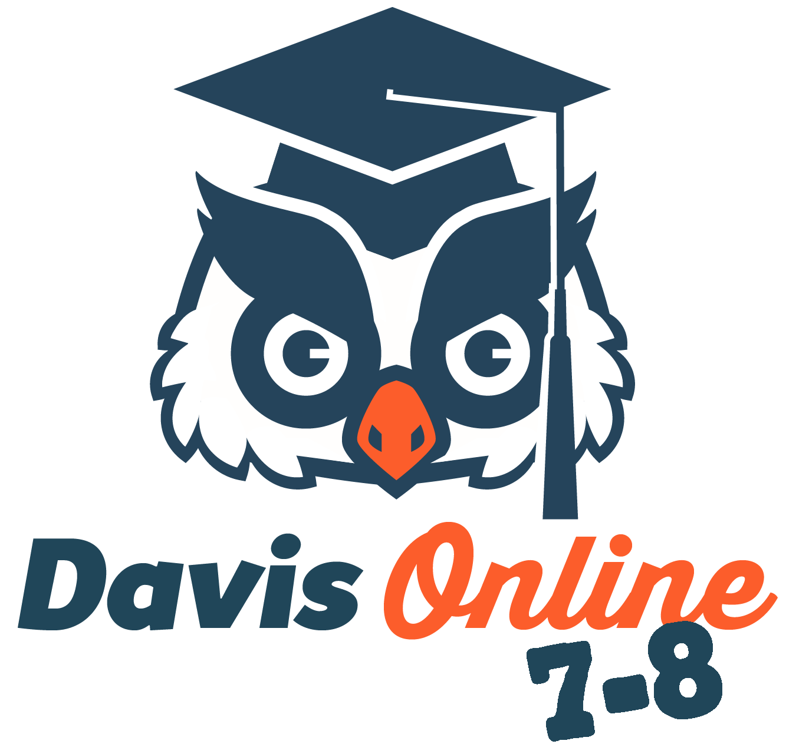
Davis Online Courses for Students in Grades 7-8

Davis Online 7-8
Davis Online allows students in 7th and 8th grades to take 4 core classes online (English, Math, Science, and Social Studies) as well as other courses at their boundary school. Students will register at their boundary school for any courses they would like to take at that location, then enroll in Davis Online courses.

This program will require:
- Students to complete work at 70% mastery and assessments at 80% mastery.
- Parental involvement
- Working computer with sound
- Internet access
- Enrollment at your Junior High Boundary School
- Training session before enrollment
If you are interested in 7th‐8th grade online courses for your student, complete the Davis Online 7-8 Interest Form and email to Sarah Ruiz,

Davis Online 7‐8 Programs Mentor, at sruiz@dsdmail.net. Submitting this form will NOT enroll your student in any program. However, it will help us contact you with more information.

DSD Online Courses for Students in Grades K-6
Davis Connect, Davis School District’s online K-6 school, offers full-time or part-time enrollment options. We provide a strong, research-based, interactive and supportive curriculum. To learn more, please visit our website: http://mydavisconnect.org

To enroll, please contact Rebecca Reeder.
E-mail: rreeder@dsdmail.net
Phone: 801-402-5342.

DSD Online Contacts
Utah Students Connect 9-12  Davis Connect 7-8  Sue E. Winkler, MEd  Online Programs Administrator, Davis School District  Administrator, Utah Students Connect  Richard E. Kendell Building  70 E. 100 N.  Farmington, UT 84025  Office 801.402.0588  Fax 801.402.5333  swinkler@dsdmail.net  Sarah Ruiz  Online Programs Mentor 7-8  sruiz@dsdmail.net  Lani Porter  Secretary  Office 801.402.5445  laporter@dsdmail.net  Davis School District Online Website  http://www.davis.k12.ut.us/Page/86930  Davis Connect 7-8 Website  http://www.davis.k12.ut.us/Page/86941  Utah Students Connect Website  http://utahstudentsconnect.org | Davis Connect K-6  Rebecca Reeder  K-6 Online Director  Richard E. Kendell Building  70 E. 100 N.  Farmington, UT 84025  Office 801.402.5342  Fax 801.402.5333  rreeder@dsdmail.net  Krista Harrah  K-6 Instructor  kharrah@dsdmail.net  Valorie Griffin  Secretary  Office 801.402.5131  vgriffin@dsdmail.net  Davis Connect K-6 Website  http://mydavisconnect.org

Links to Online Programs and Schools
Utah Students Connect http://utahstudentsconnect.org
Davis Connect http://mydavisconnect.org
Electronic High School http://schools.utah.gov/edonline/Electronic-High-School-(EHS).aspx
Public Education Online (SOEP) http://schools.utah.gov/edonline/default.aspx

